**Introduction:**

**Cellular homeostasis and ionic regulation:**

* Neural signalling requires ionic flux
* Electrochemical ion flux and Nernst potential:
* *What is the difference between diffusion and osmosis?*
  + Diffusion -net movement of ions or molecules from a region of high concentration to a region of low concentration.
  + Osmosis – diffusion of solvent molecules (e.g. water) across a semi-permeable membrane until there is an equal concentration of solutes on either side (Osmoneutrality).
    - *Why does this happen?*
* There is also a flux based on an electrical field for charged molecules = drift (based on Ohm’s law for drift)
  + *What is the equation for this law?*
  + *How do we account for the different charges on the various components along the membrane?*
* Einstein Relation states that the two fluxes diffusion and drift are additive in the same medium. This is described with the Nernst-Planck Equation (NPE).

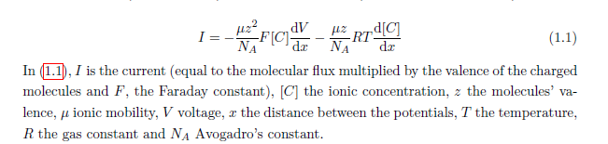

* + *How do we convert ionic current to molecular flux from a first principles perspective?*
  + *What is ionic mobility?*
  + *Why is the gas constant included in this equation?*

**

* 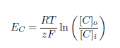Current(I) is = 0 at steady state as there is no net movement of ions. From this we can drive the Reversal or Nernst potential of an ion.
* The cellular electric field and membrane potential
* Application of electrochemical equilibria and the ionic driving force
* The Na+/K+ ATPase establishes the cellular membrane potential and volume using the pump leak mechanism